w
foster+freeman
FORENSIC SCIENCE INNOVATION
284-028
VSC90 Front OVD
PCB Assembly Test Plan

FOR INTERNAL USE ONLY

Author: Will Moore
Email: will.moore@fosterfreeman.com

Table of Contents
1 Table of Contents 2
2 Document History 3
3 Scope 3
4 Equipment List 3
4.1 Test Hardware 3
4.2 Test Software 3
5 Test Procedure 4
5.1 Supply Rail Checks 4
5.2 LED Driver Tests 4
5.3 Serial Interfaces 5
5.4 Thermal Tests 6

Document History

Version | Date | Author | Description of changes
00 | 17/04/2024 | Will Moore | Test of initial prototype design 284-028-AS-00

Scope
This document outlines the test plan for the Front OVD PCB to verify that the design functions as intended.

Equipment List

Test Hardware

ID | Description | Quantity | Serial Number
[H01] | Dual Bench PSU | 1 | -
[H02] | Bus Pirate & Probe kit | 1 | -
[H03] | Handheld DVM | 1 | 93160508
[H04] | Thermal Camera | 1 | 894069188
[H05] | Oscilloscope | 1 | C042644

Test Software

ID | Description | Version
[S01] | COMport | 1.01.19

COMport Quick Command Setup, Page 1:

"Configure buspirate"=m4\n3\nP\n
"Configure IOExp"=[0x42 0x0A 0x80] [0x42 0x1A 0x08] [0x42 0x00 0x00] [0x42 0x10 0x00]\n
"LED1" =[0x42 0x1A 0x00] [0x42 0x0A 0x00] [0x42 0x1A 0x02] [0x42 0x1A 0x0A]\n
"LED2" =[0x42 0x1A 0x00] [0x42 0x0A 0x00] [0x42 0x1A 0x04] [0x42 0x1A 0x0C]\n
"LED3" =[0x42 0x1A 0x00] [0x42 0x0A 0x00] [0x42 0x1A 0x80] [0x42 0x1A 0x88]\n
"LED4" =[0x42 0x1A 0x00] [0x42 0x0A 0x01] [0x42 0x1A 0x08]\n
"LED5" =[0x42 0x1A 0x00] [0x42 0x0A 0x02] [0x42 0x1A 0x08]\n
"LED6" =[0x42 0x1A 0x00] [0x42 0x0A 0x04] [0x42 0x1A 0x08]\n
"LED7" =[0x42 0x1A 0x00] [0x42 0x0A 0x08] [0x42 0x1A 0x08]\n
"LED8" =[0x42 0x1A 0x00] [0x42 0x0A 0x10] [0x42 0x1A 0x08]\n
"LED9" =[0x42 0x1A 0x00] [0x42 0x0A 0x20] [0x42 0x1A 0x08]\n
"LED10"=[0x42 0x1A 0x00] [0x42 0x0A 0x40] [0x42 0x1A 0x08]\n
"LED11"=[0x42 0x1A 0x00] [0x42 0x0A 0x80] [0x42 0x1A 0x08]\n
"LEDS OFF"=[0x42 0x1A 0x00] [0x42 0x0A 0x00]\n

Page 2:

"LED11 DAC0"=[0x42 0x1A 0x00] [0x42 0x0A 0x80] [0x42 0x1A 0x08]\n
"LED11 DAC1"=[0x42 0x1A 0x10] [0x42 0x0A 0x80] [0x42 0x1A 0x18]\n
"LED11 DAC2"=[0x42 0x1A 0x20] [0x42 0x0A 0x80] [0x42 0x1A 0x28]\n
"LED11 DAC3"=[0x42 0x1A 0x30] [0x42 0x0A 0x80] [0x42 0x1A 0x38]\n
"LED11 DAC4"=[0x42 0x1A 0x40] [0x42 0x0A 0x80] [0x42 0x1A 0x48]\n
"LED11 DAC5"=[0x42 0x1A 0x50] [0x42 0x0A 0x80] [0x42 0x1A 0x58]\n
"LED11 DAC6"=[0x42 0x1A 0x60] [0x42 0x0A 0x80] [0x42 0x1A 0x68]\n
"LED11 DAC7"=[0x42 0x1A 0x70] [0x42 0x0A 0x80] [0x42 0x1A 0x78]\n
"LEDS OFF"=[0x42 0x1A 0x00] [0x42 0x0A 0x00]\n

Test Procedure

PCB Version Tested: | 284-028-AS-00

Supply Rail Checks

ID | Test | Limits/Criteria | Result | Comments
 | Using the DVM, measure the resistance of the +3V3 rail to GND | >10k | >100k
 | Using the DVM, measure the resistance of the +12V rail to GND | >10k | >100k
 | Using the DVM, measure the resistance of the LED_OUT rail to GND | >10k | >100k

LED Driver Tests

ID | Test | Limits/Criteria | Result | Comments
- | - Connect the Bus Pirate probes to the UUT I2C lines.  - Ensure the VPU probe is connected to the 3V3 supply as the UUT does not have pullups.  - Power up the UUT with 12V and 3.3V.  - Run the “Configure Buspirate” and “Configure IOExp” commands in COMport. | - | -
 | Run the LED11 command, verify that only LED11 lights up. | Pass/Fail | P
 | Measure the voltage on TP5 (LED-). | 207-217 mV | 212 mV
 | Measure the voltage across TP5 (LED-) – TP6 (LED+). | 2.8-3.0 V | 2.86 V
 | Run the LED1 command, verify that only LED1 lights up. | Pass/Fail | P
 | Run the LED2 command, verify that only LED2 lights up. | Pass/Fail | P
 | Run the LED3 command, verify that only LED3 lights up. | Pass/Fail | P
 | Run the LED4 command, verify that only LED4 lights up. | Pass/Fail | P
 | Run the LED5 command, verify that only LED5 lights up. | Pass/Fail | P
 | Run the LED6 command, verify that only LED6 lights up. | Pass/Fail | P
 | Run the LED7 command, verify that only LED7 lights up. | Pass/Fail | P
 | Run the LED8 command, verify that only LED8 lights up. | Pass/Fail | P
 | Run the LED9 command, verify that only LED9 lights up. | Pass/Fail | P
 | Run the LED10 command, verify that only LED10 lights up. | Pass/Fail | P
 | Run the LED11 command, verify that only LED11 lights up. | Pass/Fail | P
 | Run the LED OFF command, verify that all LEDs turn off. | Pass/Fail | P
 | Measure the voltage on TP4 (LED+). | <0.1 V | 0.001 V
 | Run the LED11 DAC1 command, measure the voltage on TP5 (LED-). | 191-201 mV | 196 mV
 | Run the LED11 DAC2 command, measure the voltage on TP5 (LED-). | 173-183 mV | 178 mV
 | Run the LED11 DAC3 command, measure the voltage on TP5 (LED-). | 157-167mV | 162 mV
 | Run the LED11 DAC4 command, measure the voltage on TP5 (LED-). | 139-149 mV | 146 mV
 | Run the LED11 DAC5 command, measure the voltage on TP5 (LED-). | 123-133 mV | 129 mV
 | Run the LED11 DAC6 command, measure the voltage on TP5 (LED-). | 105-115 mV | 111 mV
 | Run the LED11 DAC7 command, measure the voltage on TP5 (LED-). | 89-99 mV | 94 mV
- | - Run the LED OFF command.  - Configure the scope to measure voltage overshoot on TP4 (LED+).  - Run the LED1 command.
 | Measure the voltage overshoot on TP4 (LED+). | </= 3.42 V | 3.26 V
 | Measure the peak to peak voltage ripple on TP4 (LED+). | < 50 mV | 19.2 mV

Serial Interfaces

ID | Test | Limits/Criteria | Result | Comments
- | TBD, check I2C signal integrity at system integration as pullups are on host board at end of ribbon.  Use the Oscilloscope to monitor the I2C communications on TP9 and TP10.
 | Measure the frequency of the SCL signal (TP9). | tbc
 | Measure the high level of the SCL signal (TP9). | 2.7 – 3.4 V
 | Measure the low level of the SCL signal (TP9). | 0 – 0.6 V
 | Measure the rise time of the SCL signal (TP9). | < 1000 ns
 | Measure the fall time of the SCL signal (TP9). | < 300 ns
 | Measure the peak overshoot of the SCL signal (TP9). | 2.7 – 3.4 V
 | Measure the peak undershoot of the SCL signal (TP9). | -0.5 – 0.6 V
 | Measure the high level of the SDA signal (TP10). | 2.7 – 3.4 V
 | Measure the low level of the SCL signal (TP10). | 0 – 0.6 V
 | Measure the rise time of the SCL signal (TP10). | < 1000 ns
 | Measure the fall time of the SCL signal (TP10). | < 300 ns
 | Measure the peak overshoot of the SCL signal (TP10). | 2.7 – 3.4 V
 | Measure the peak undershoot of the SCL signal (TP10). | -0.5 – 0.6 V

Thermal Tests

ID | Test | Limits/Criteria | Result | Comments
- | Run the LED11 command and leave for 10 minutes, whilst monitoring the LED’s temperature with the thermal camera. | - | -
 | Record the room temperature. | - | 21°C
 | Record the temperature of LED11.  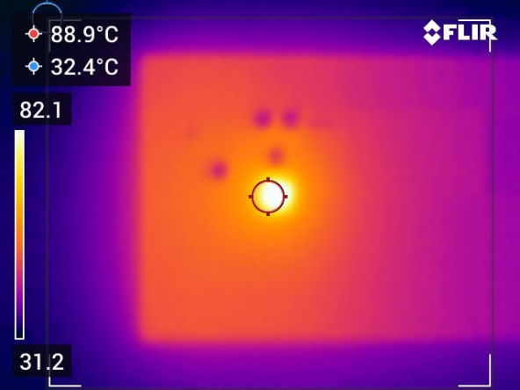 | < 100°C | 88.9°C | Datasheet spec: Tj max = 135°C  Note this is the average/best case for LED heatsinking in the design.
- | Run the LED3 command and leave for 10 minutes, whilst monitoring the LED’s temperature with the thermal camera. | - | -
 | Record the temperature of LED3.  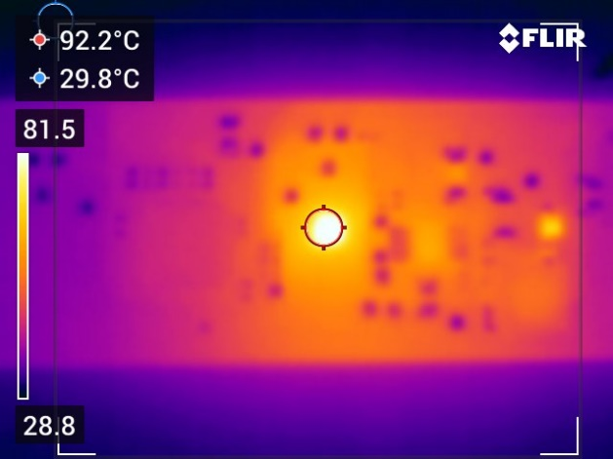 | <100°C | 92.2°C | Datasheet spec: Tj max = 135°C  Note this is the worst case for LED heatsinking in the design.  Note IC2 driver is adjacent to this LED, temp reads much less than 92°C, Tj max = 150°C so well within spec.
- | The thermal camera was used to monitor any other component temperatures over the whole PCB, focusing on maximum temperatures and/or any components of interest. | - | -
 | D1 (Catch Diode), with closest LED turned on (LED2).  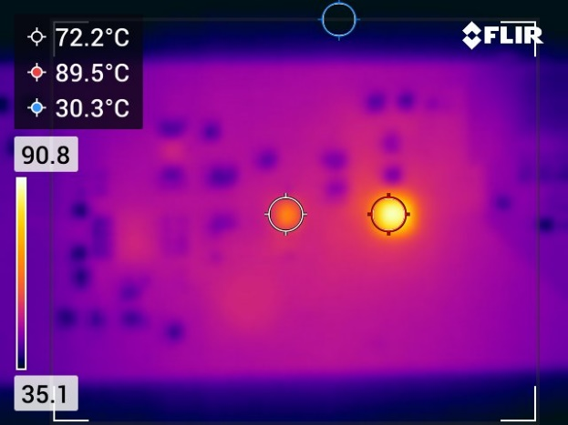 | <115°C | 72.2°C | Datasheet spec: Tj max = 150°C

